**CMPE 272 – Project**

**Git URL(**[**https://github.com/SJSU272LabF17/Project-Team-21**](https://github.com/SJSU272LabF17/Project-Team-21)**)**

**OrganChain: -**

1. Organ donors visits the OrganChain site and reads about organ donation

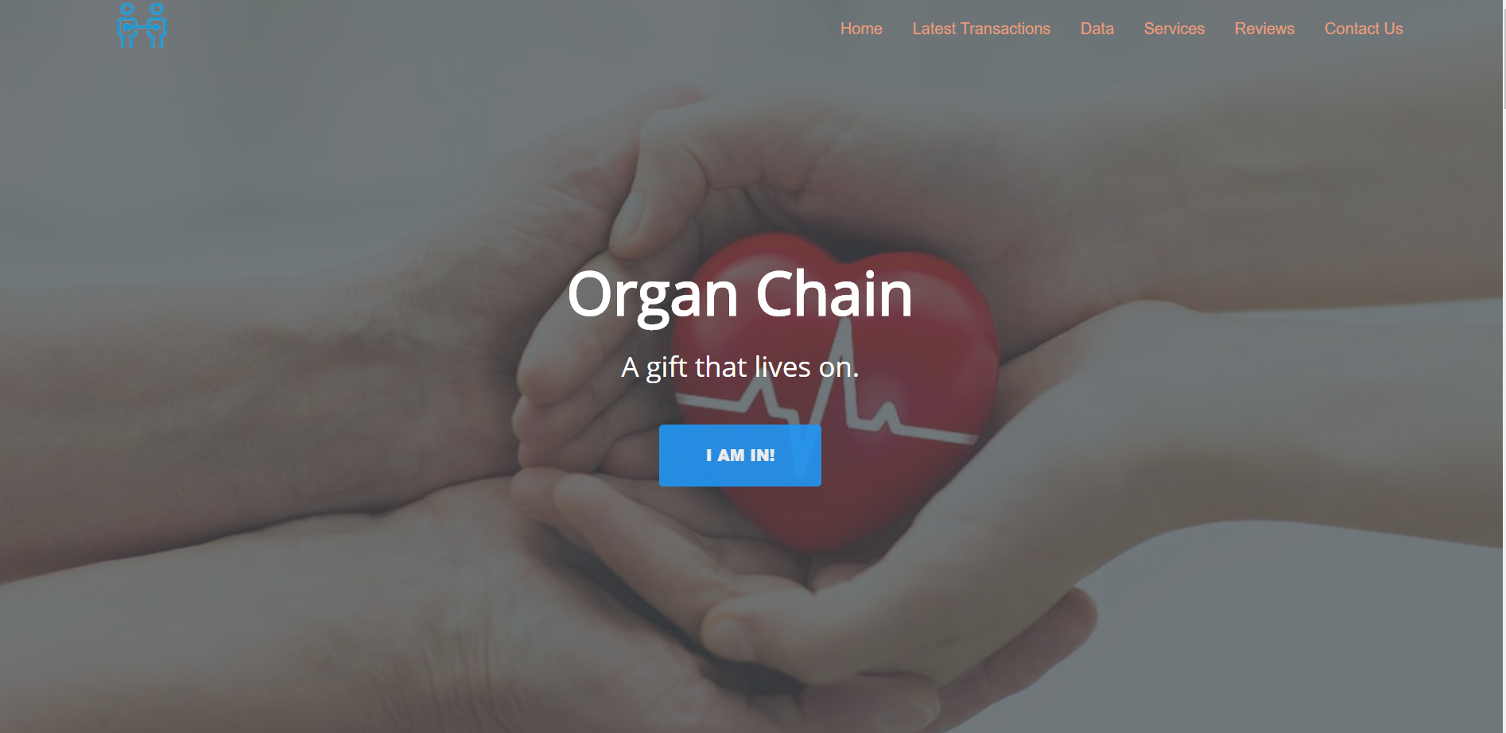

1. Donor sees all latest transactions and creates a donor account and logs in

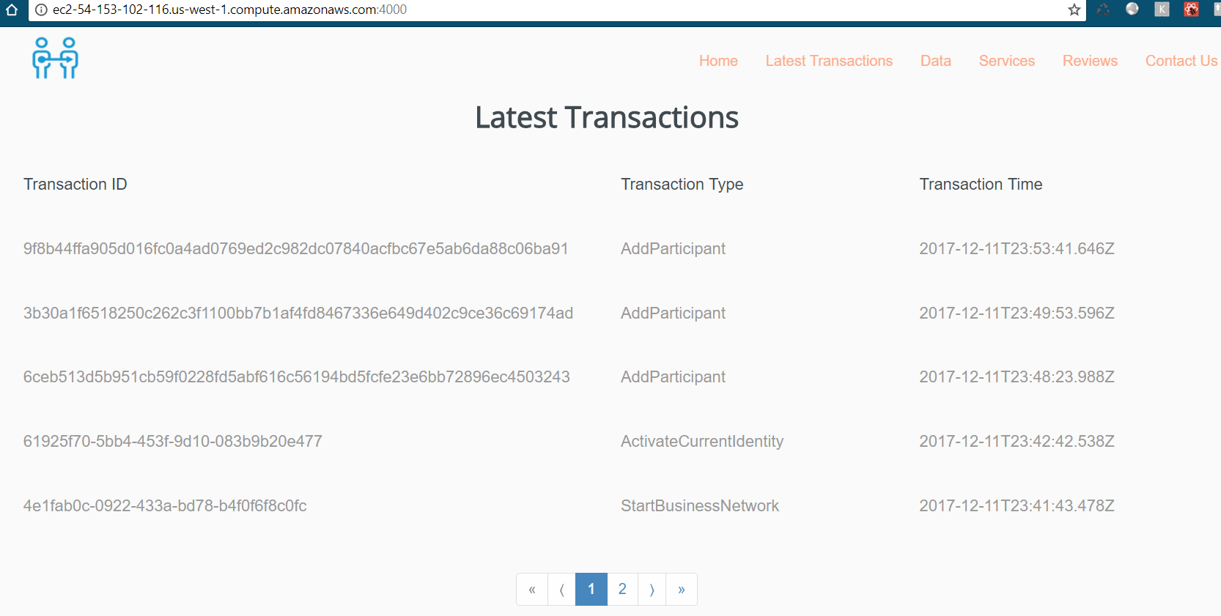

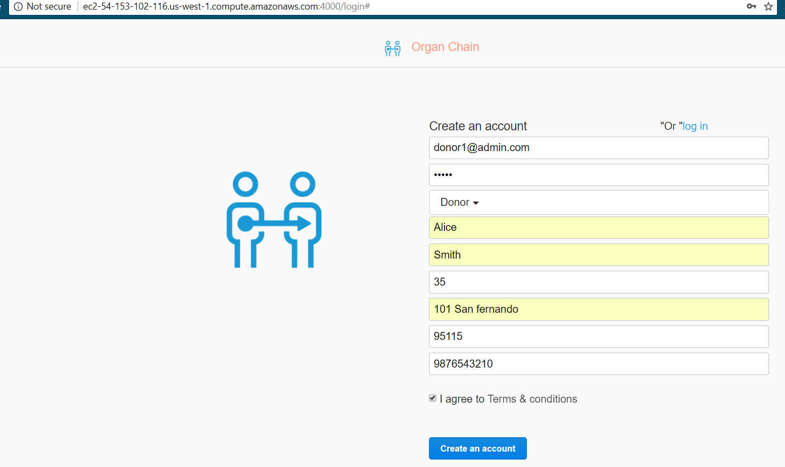

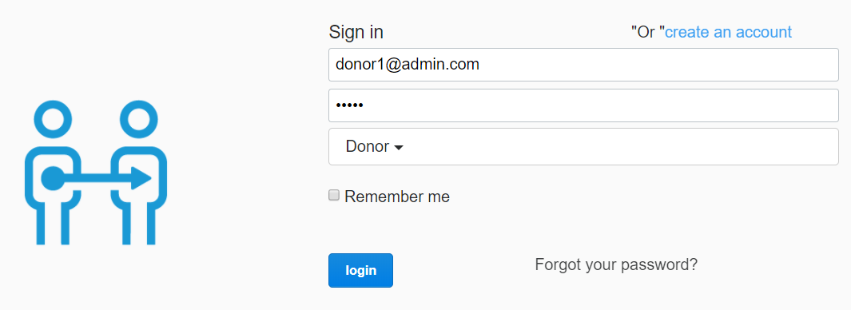

1. Donor sees his/her own profile

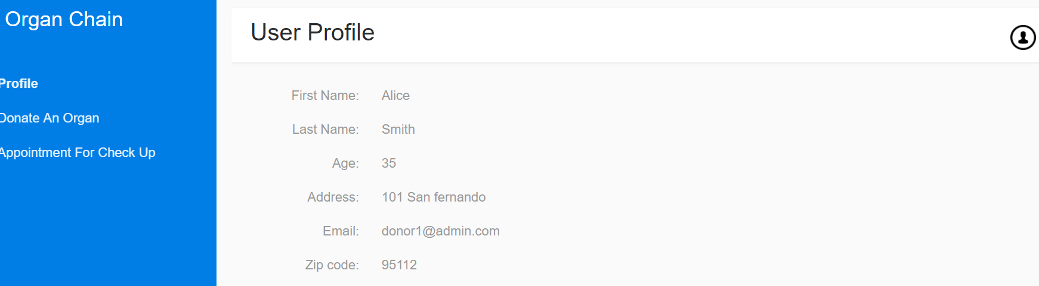

1. Donor registers his/her organ

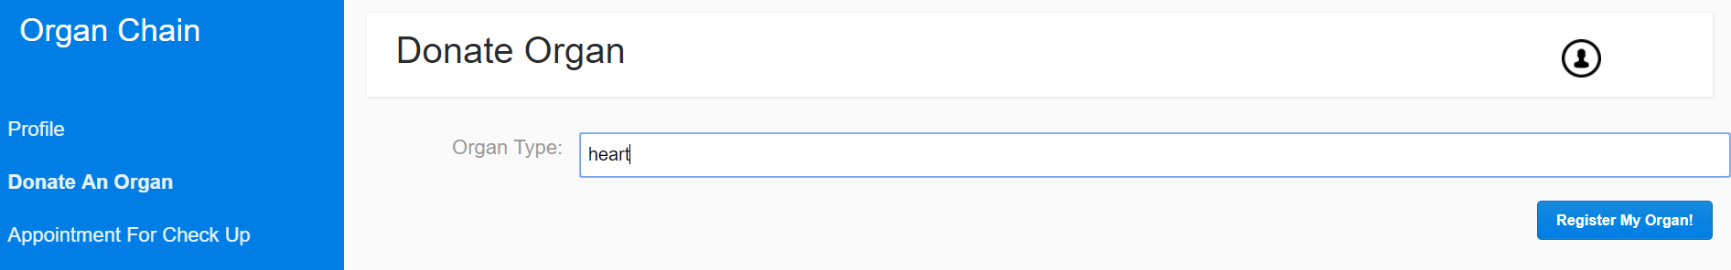

1. Donor picks a hospital to make an appointment for medical testing

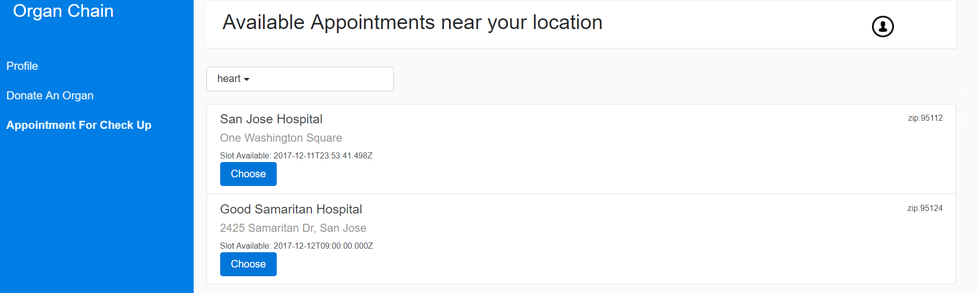

1. Once donor schedules an appointment, the appointment will appear instead of list of hospitals

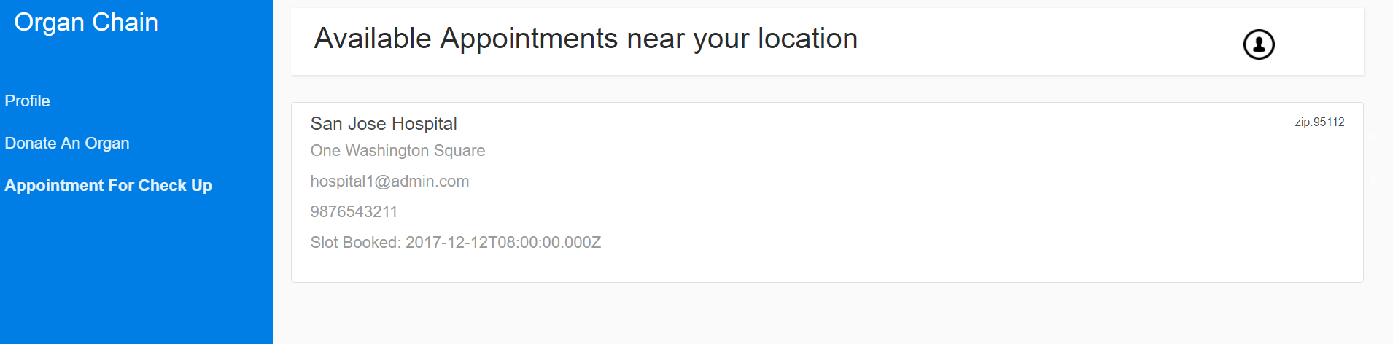

1. This appointment will appear in hospital’s appointment list

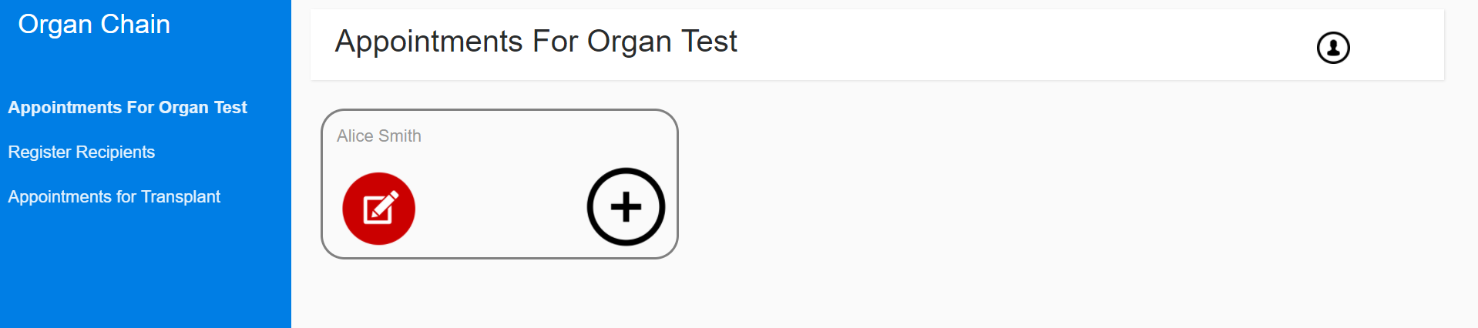

1. Hospital conducts tests, gathers data and shares with UNOS

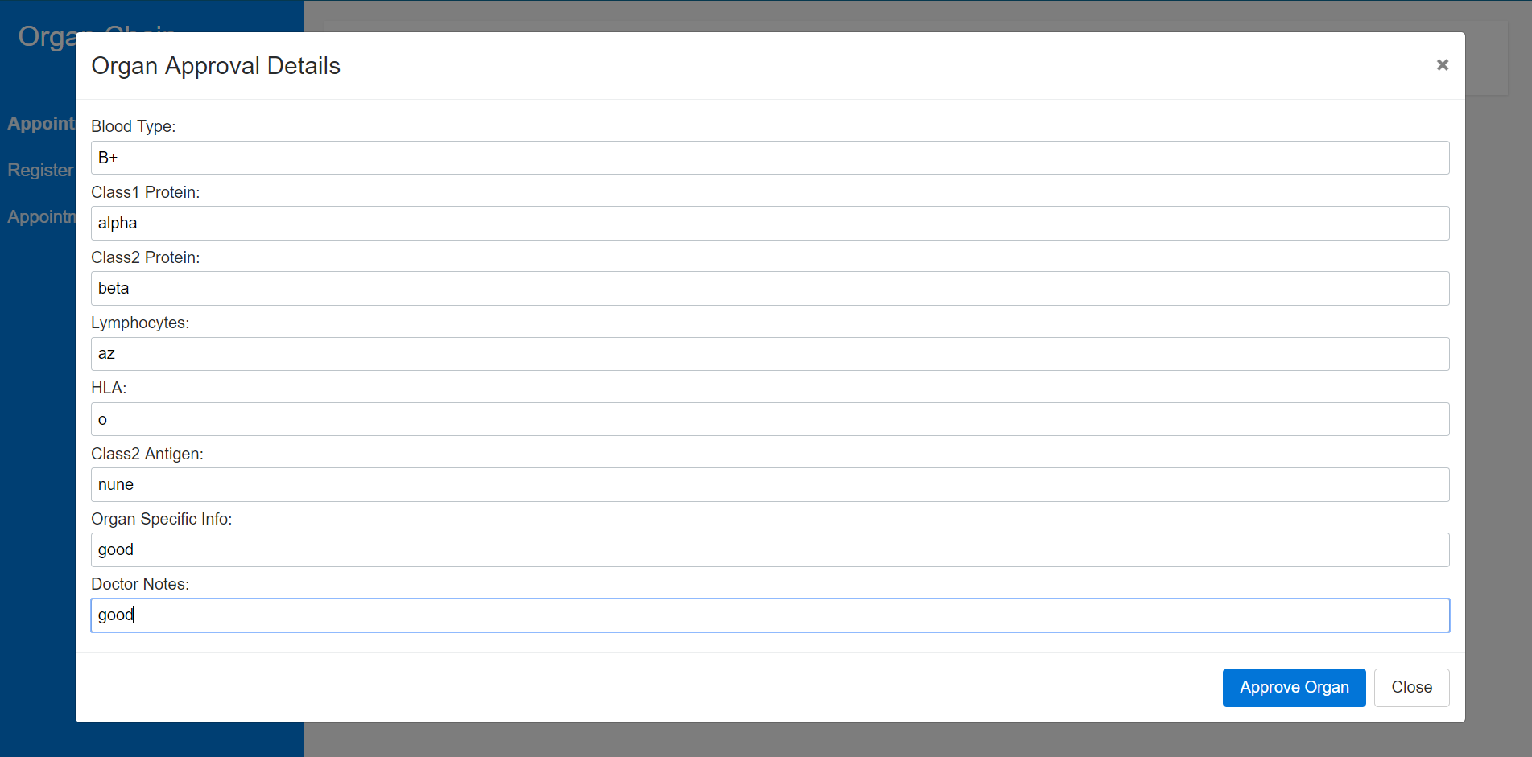

1. Other hospitals add recipients and share with UNOS

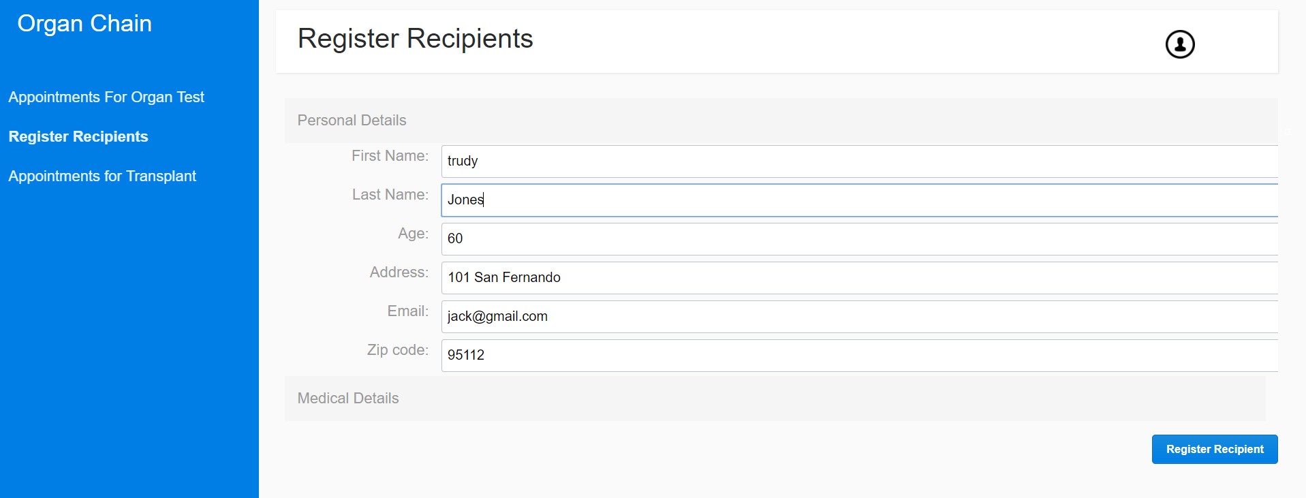

1. Now organ will appear in UNOS list to get recipient assigned.

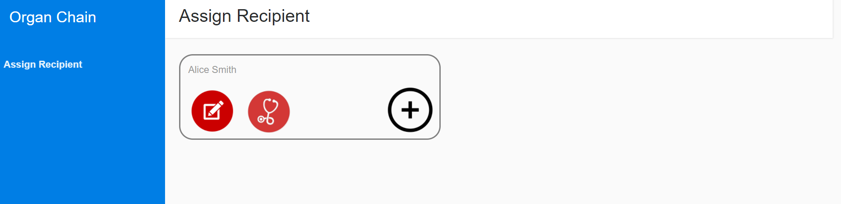

1. UNOS matches suitable donor-recipient organ pairs and generates appointment for transplant

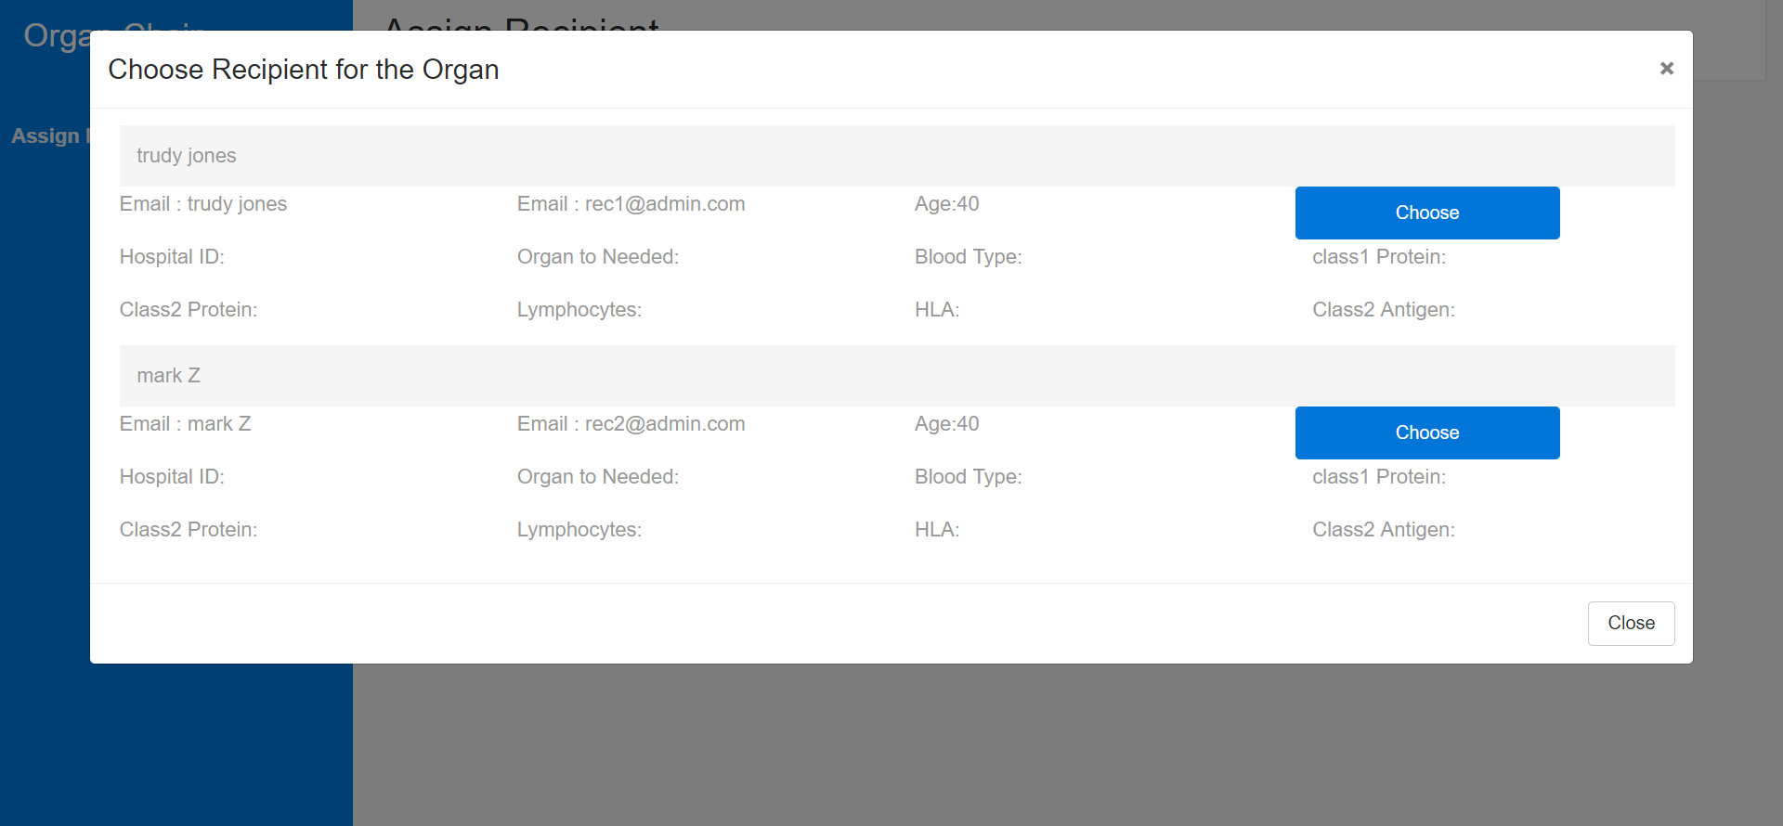

1. Now this organ will appear in hospital transplant appointment. Hospital where recipient registered himself/herself.

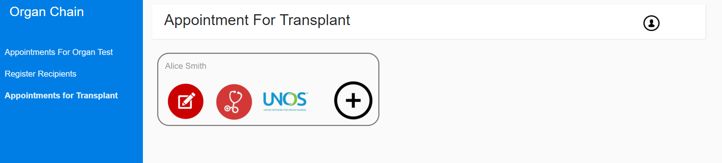

1. The recipient hospital performs transplant and organ cycle gets completed!

